**Assignment 10B - Chapter 6**

1. DB diagram reviewed and ensured for complete design and normalization
2. Database created in SQL Server
3. Created tables in the new VinceVinyl Database
4. Created Database Diagram and relationships

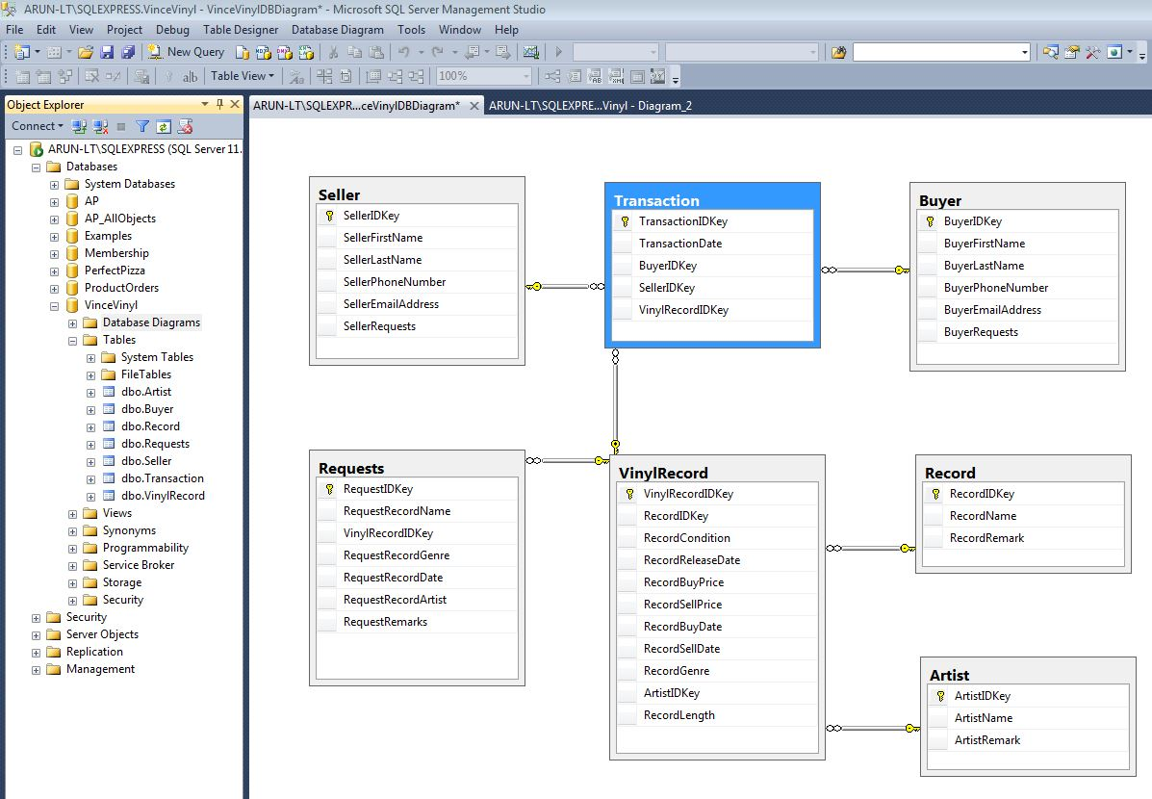

1. Sample data added and diagrams for your perusal

Artist sample data

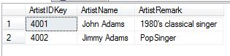

Buyer sample data

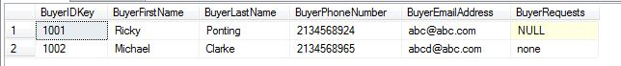

Record sample data

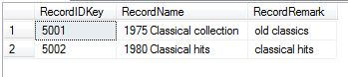

Request sample data

RequestTableSampleData.JPG

Seller sample data

SellerTableSampleData.JPG

Transaction sample data

TransactionTableSampleData.JPG

Vinyl Record sample data

VinylRecordTableSampleData.JPG

1. Data Dictionary

Artist data dictionary

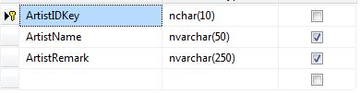

Buyer data dictionary

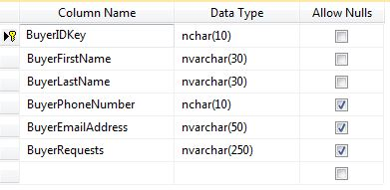

Record data dictionary

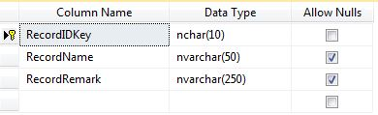

Request data dictionary

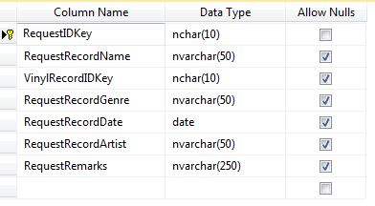

Seller data dictionary

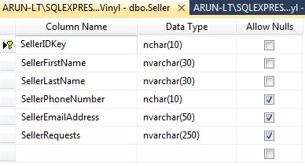

Transaction data dictionary

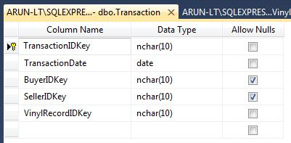

Vinyl record data dictionary

